Everyone setup this project & implement the requirements, make sure that all term should be clear with proper documented form with project architecture. Deadline is 1st July 2024 no one will allow from Monday without completion of project.

Build Project Java based ERP Application Project:

------------------------------------------------------

Requirement:

----------------

1. Setup New Customized VPC, do not use existing default VPC.

2. Create 1 Public Subnet & 1 Private Subnet.

3. Create separate Security group for Network, Public Server & Private Server with required whitelisted port.

4. Setup the RDS with no public access with Automated backup, with retention period of 5 days. Set the maintenance window of every 3rd week for 30 mins

5 Setup the RDS with private subnet.

6. Make sure that RDS Backup will store into the another region.

7. Setup the java based tomcat backend application tomcat version 9.0 higher. Java version should be open-jdk 17.

8. setup the backend app with database RDS- Instance should be in private subnet, here implement the bastion host concept, configure the backend from public subnet..

9. Implement the 3-tier architecture here with the setup of reverse proxy using nginx version 1.20.

10. Implement the NACL with deny rule for host machine ip with lowest range from default one.

11. Implement the VPC Network log, log should be in S3 and implement the server logs in centralized service.

12. Implement the Train on all resources & services that we created & trail should be available in s3.

13. Setup the one monitoring dashboard for Network, Server CPU, Server Memory, Server Network IOPS.

14. Create the autoscaling for backend application server. (desired= 5, Minimum=3, Maximum=10)

15. Setup the alarm with 50% CPU utilisation with a simple scaling policy.

16. Make the documentation & flow diagram for the project.

Step 1: Setup Customized VPC:

Go to the VPC console on AWS 🡪 Create a new VPC with a CIDR block of 10.0.0.0/16 🡪 Create VPC

Open vpc CONSOL

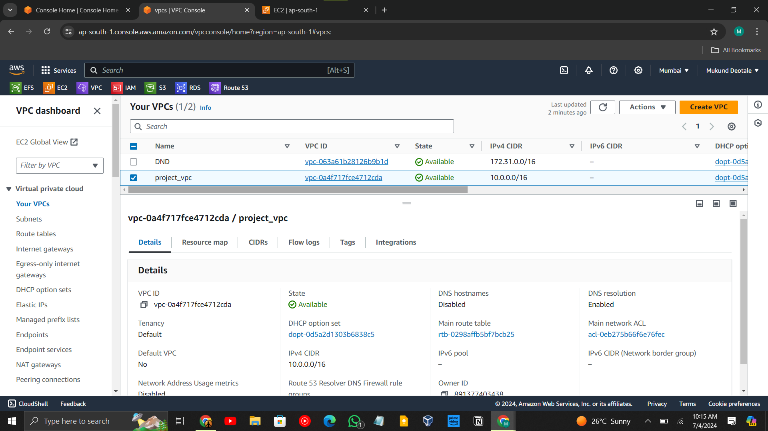

**Public subnet:**

🡪go to subnet 🡪 create subnet 🡪 select vpc 🡪 give public subnet name (my_PublicSubnet)🡪chose availability zone 🡪chose vpc 🡪 give IPv4 subnet CIDR block (10.0.1.0/24)🡪 create subnet 🡪 select public subnet 🡪 action 🡪 edit subnet settings🡪 Enable auto-assign public IPv4 address 🡪 **save**

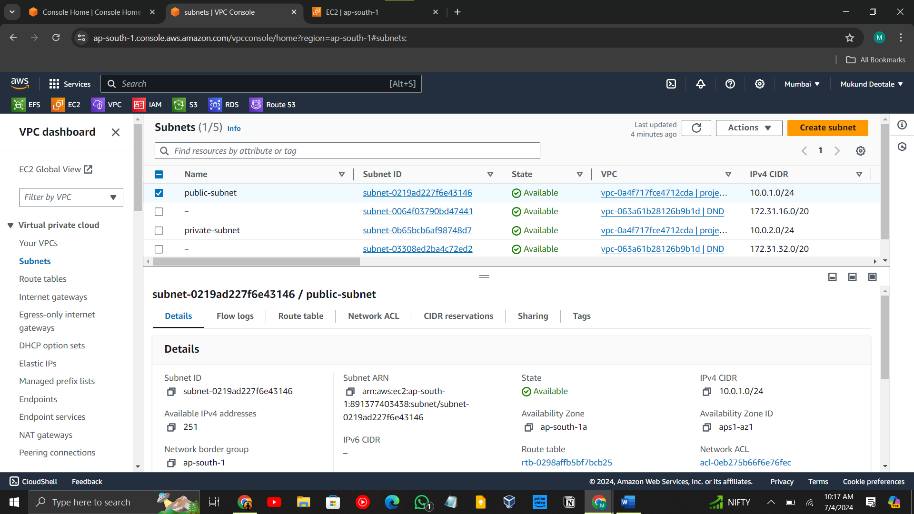

**Private subnet:**

**🡪** go to subnet 🡪 create subnet 🡪 select vpc 🡪 give private subnet name (my_privateSubnet)🡪chose availability zone to different from public 🡪chose vpc 🡪 give IPv4 subnet CIDR block (10.0.2.0/24)🡪 **create subnet**

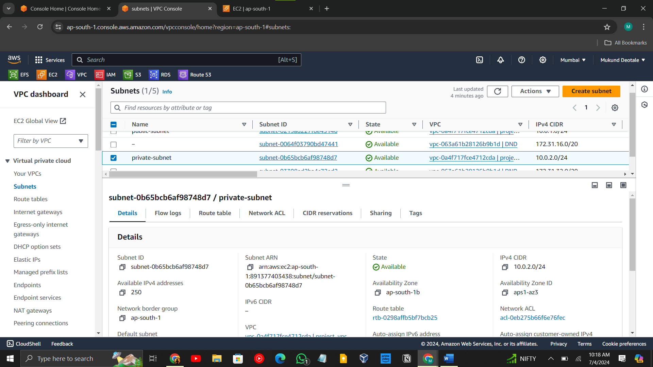

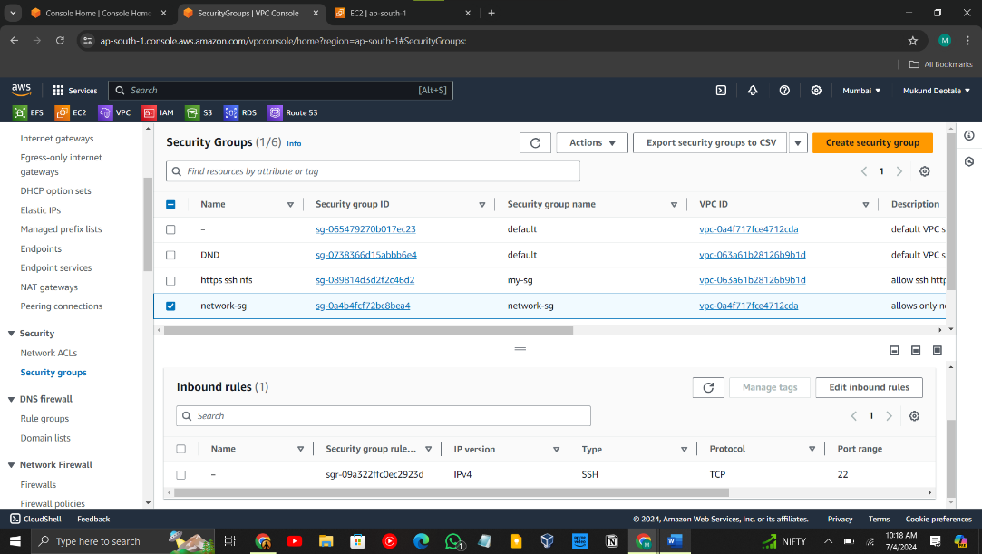Step 2: Create Security Groups:

**Create 3 Security Groups:**

Network Security Group:

Name: NetworkSG

Description: Allow SSH access

VPC: my_vpc01

Inbound Rule: Type: SSH

Protocol: TCP

Port range: 22

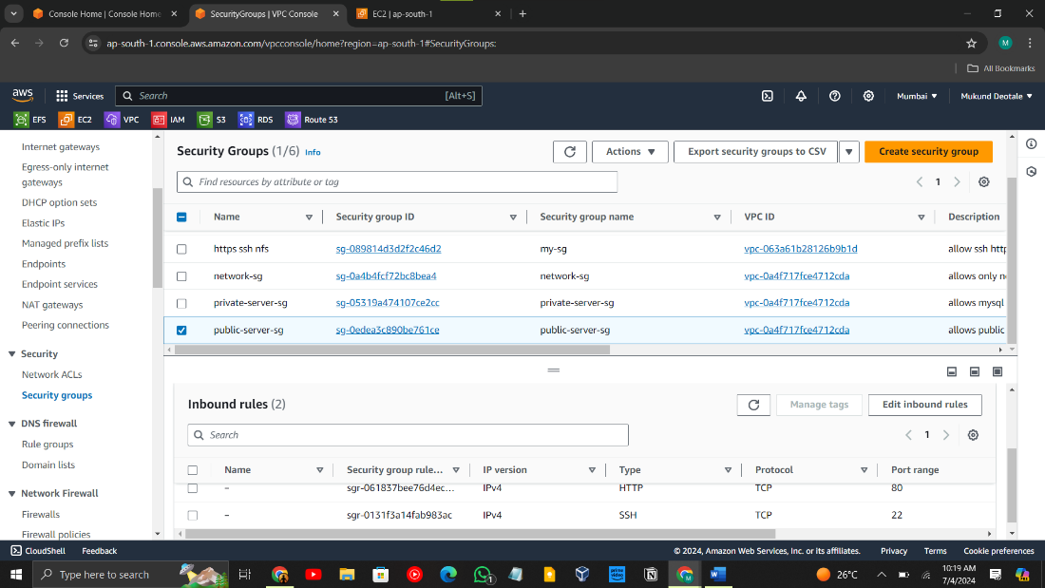Public Server Security Group:

Name: PublicSG

Description: Allow HTTP access

VPC: my_vpc01

Inbound Rule: Type: HTTP

Protocol: TCP

Port range: 80

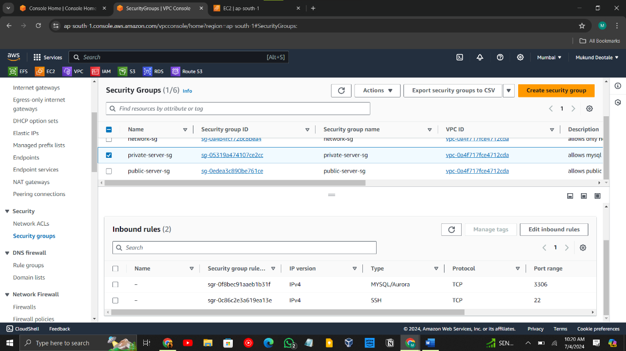

Private Server Security Group:

Name: PrivateSG

Description: Allow MySQL access

VPC: my_vpc01

Inbound Rule: Type: MySQL/Aurora

Protocol: TCP

Port range: 3306

Go to the Rout table and create two route tables one for the public subnet and one for the Pvt subnet:

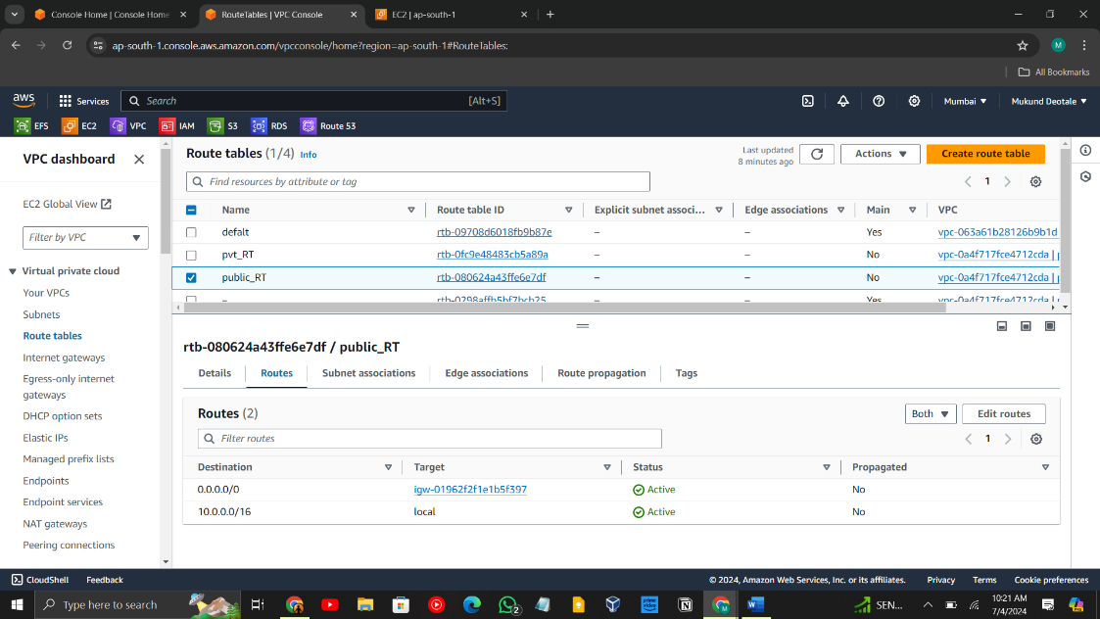Here igw attached to the public route table:

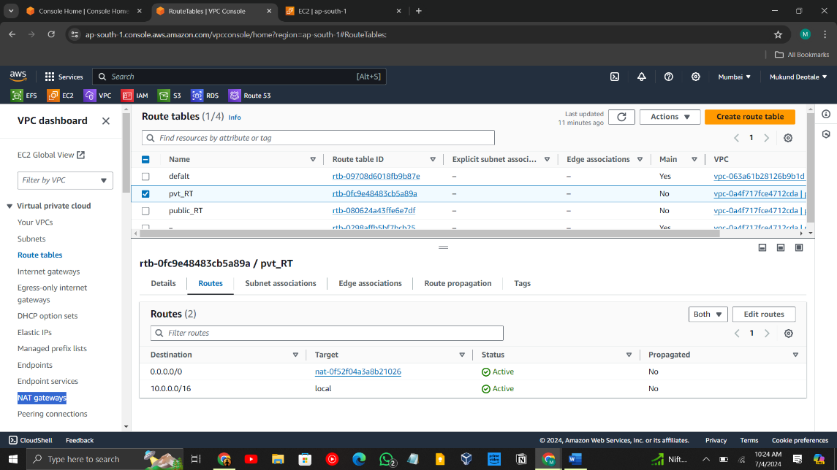**Private route table:**

**Here NAT gateways are attached:**

**Set up an ec2 instance 1 public and 1 private**

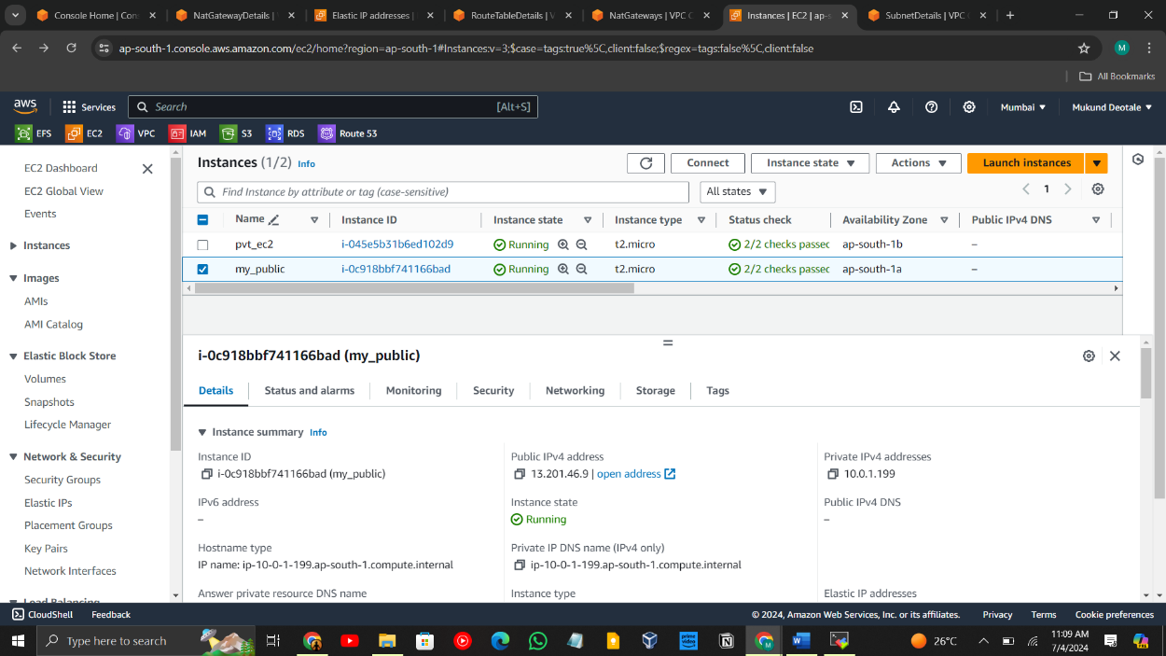**Public instance:**

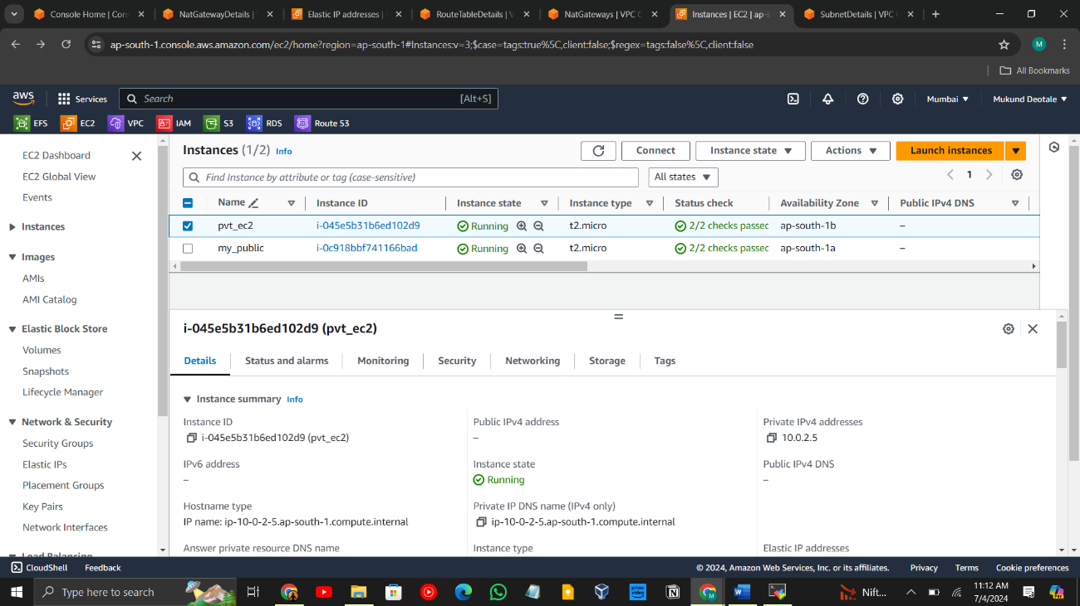**Private Instance:**

Step 3: Setup RDS Instance:

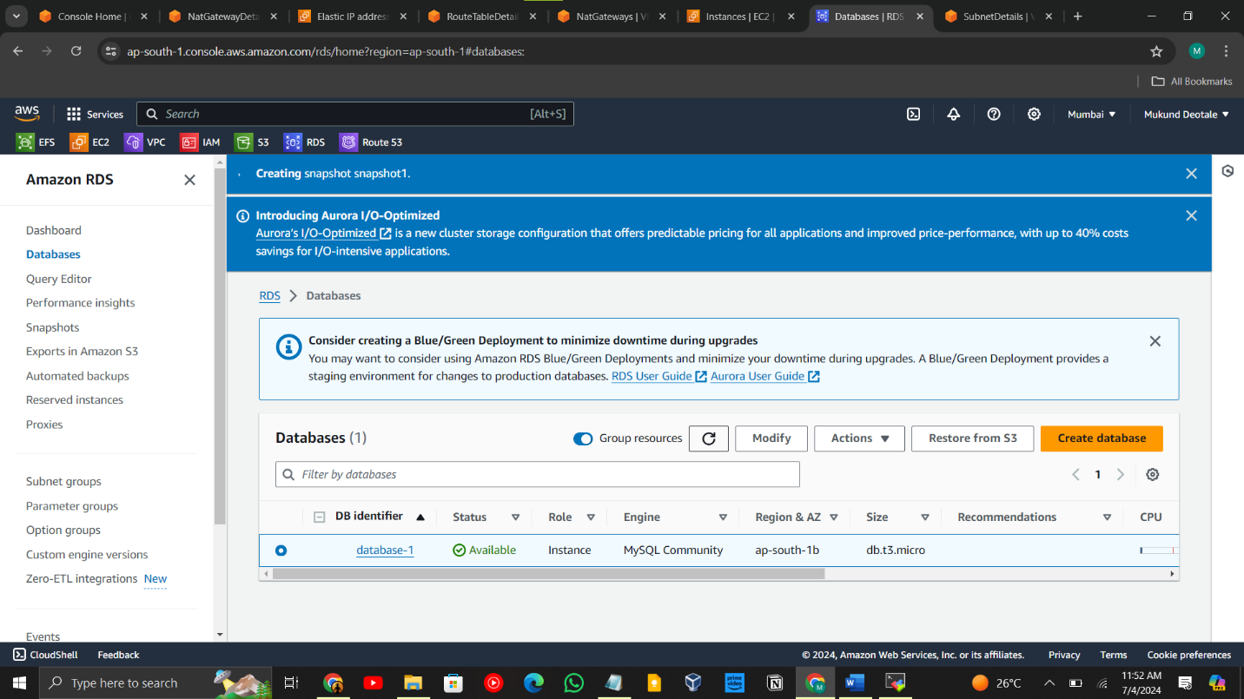Go to the RDS database dashboard 🡪 click on create database 🡪 standard create 🡪 Engine type: MySQL🡪 Version: Select the desired MySQL version 🡪 templets (free tier)🡪 settings give name (MyERPDatabase)🡪 Credentials Settings (master username) admin 🡪 Credentials management (managed by AWS)🡪 Instance configuration (db.t3. micro)🡪 Storage type (General Purpose SSD (gp2))🡪 allocate storage 20gb🡪 in connectivity chose vpc (my_vpc01)🡪 Public access(no)🡪 Existing VPC security groups (PrivateSG) 🡪 Availability Zone (ap-south-1a)🡪 Database options database name (ERPDB)🡪 Enable automated backups(yes) 🡪 Backup retention period(5days)🡪 Auto minor version upgrade (Yes)🡪 Maintenance (Maintenance window Sunday 3:00 for 30 min)🡪 **create database**

Set up RDS backup storage in another region:

Go to the RDS Dashboard, select your RDS instance 🡪 Click on "Actions" and select "Take snapshot" 🡪 give name to snapshot(snapshot01)🡪 Copy Snapshot to Another Region: After the snapshot is created, go to the "Snapshots" section 🡪 select the snapshot, click on "Actions", and select "Copy snapshot"🡪 Destination region: Choose the desired region (us east north Virginia)🡪New DB snapshot identifier: Enter a new name for the copied snapshot(newsnapshot01) 🡪 Click "Copy snapshot".

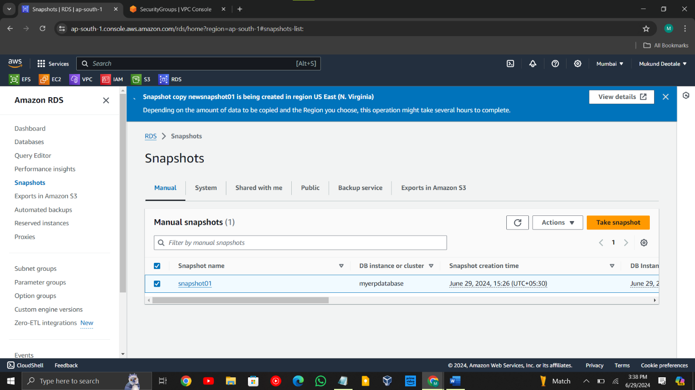

Step 4: Setup Tomcat Backend Application:

Navigate to the EC2 Dashboard🡪 Configure Instance🡪Instance Type: Choose an instance type (e.g., t2.micro for testing)🡪Network: Select myvpc01 🡪Subnet: Select PrivateSubnet 🡪Auto-assign Public IP: Disable🡪 Configure Security Group🡪Select the existing networks which allow inbound traffic on port 3306 (MySQL) 🡪 select key 🡪 **create an instance** 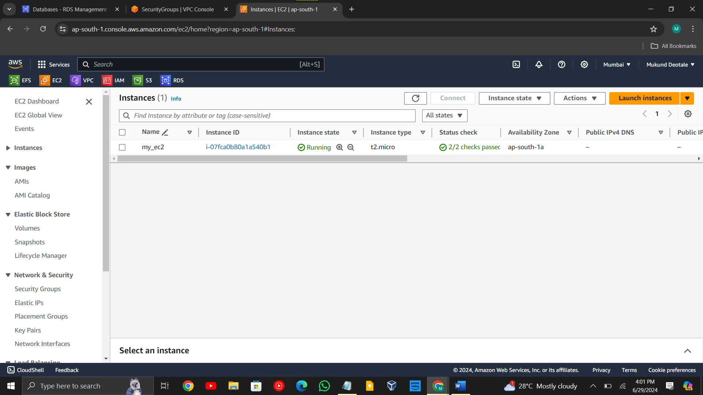

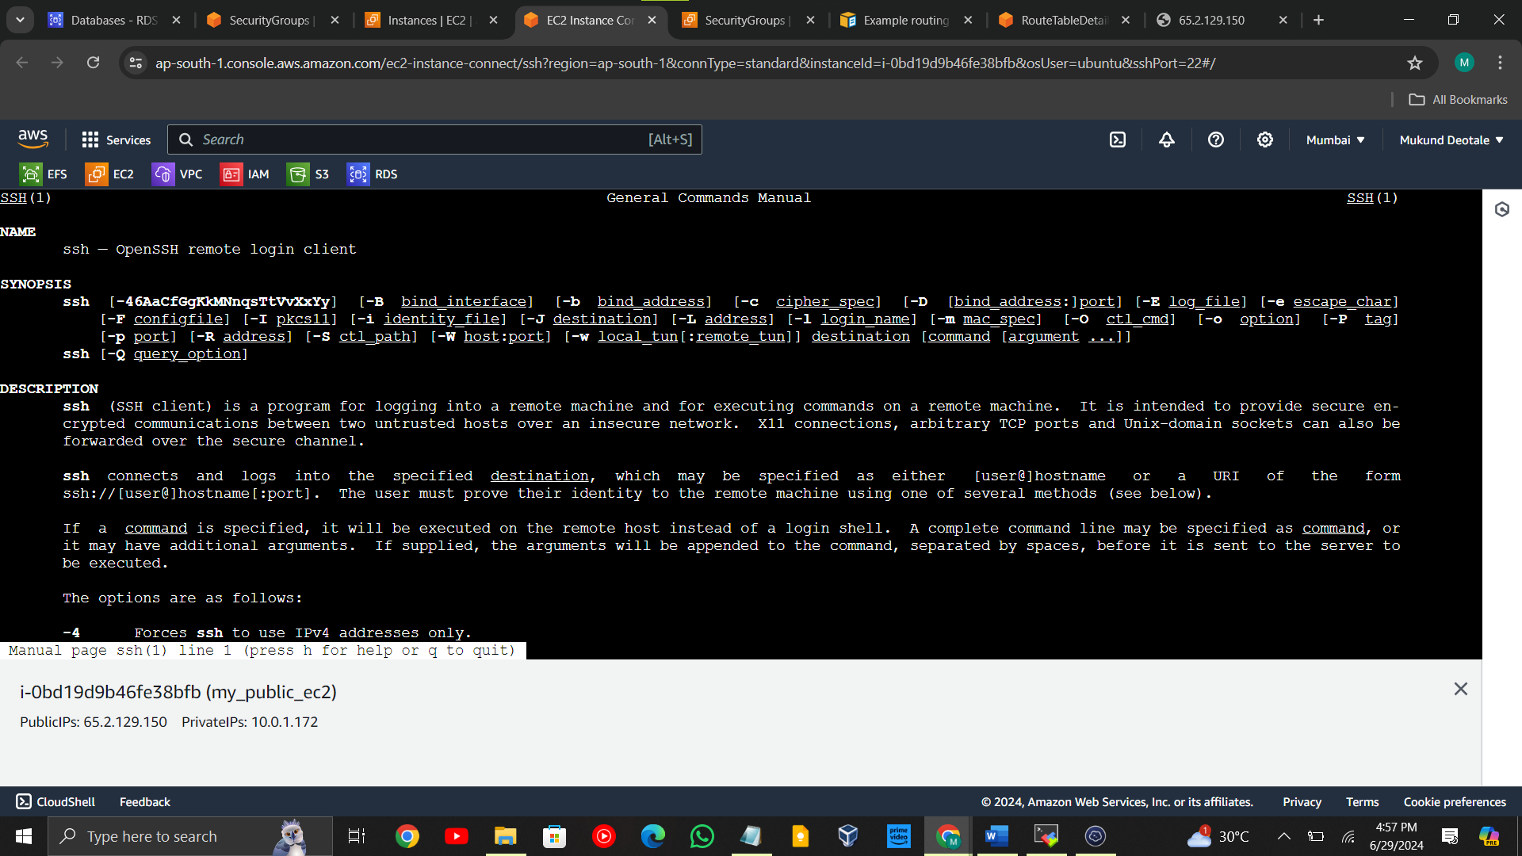

SSH into the Backend Server via Bastion Host: 🡪SSH into the Bastion host first🡪 Create new ec2 instance with public subnet 🡪 SSH access the bastion host(new ec2 instance )🡪 create a key in this instance using vim editor 🡪 by copy the key from host pc to server 🡪 chmod 400 key name (to secure the key )🡪 From the bastion host, SSH into the backend server using its private IP address🡪 **log in to the private server**

